EASTER STORY WREATH

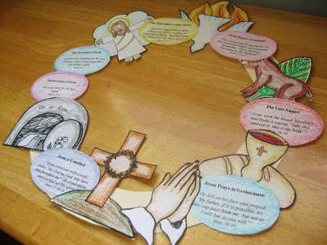
To assemble the wreath simply print, color and cut out the images. For a wreath base I used a large circle (approx. 11 1/2 " in diameter) cut from a 12" x 12" piece of cardstock:
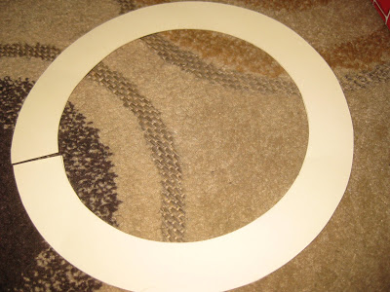
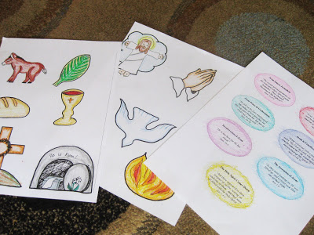
I arranged the pictures to "tell" the story from Palm Sunday (starting on the top right) through Pentecost (placed in the top center). If you're interested in making this wreath I'm sure you're already very familiar with the order of the events, but I will go ahead and list them just in case:
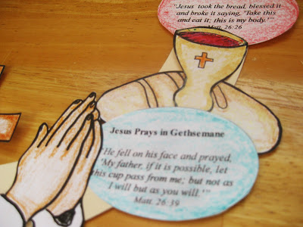
1. Jesus enters Jerusalem (palm branch and donkey pictures)
2. The Last Supper (bread and wine pictures)
3. Jesus Prays in Gethsemane (praying hands picture)
4. Jesus is Crucified (cross picture)
5. Resurrection (empty tomb picture)
6. Ascension (Jesus in clouds picture)
7. Holy Spirit Comes Down (dove and flames pictures)
Here is an example of an assembled wreath will look like:
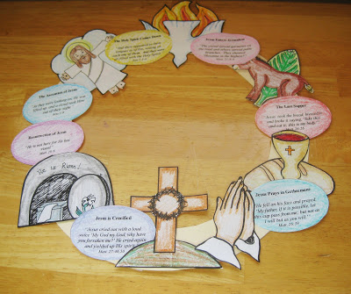
I overlapped some of the pictures on top of each other to make them fit nicely--feel free to arrange them however you like! Glue stick or Glue Dots work well to affix the pictures to the wreath base.
I hope this wreath helps make the Easter season more meaningful for your family!

-taken from the site: WeeLittleMiracles.com

